**Annual Leave Entitlements**

Currently employees with entitlement to book and take annual leave have their leave recorded in either days or hours, dependent on their working pattern.

However, from Monday 26th February all annual leave and public holidays will be managed in hours. Entitlements are not affected by this change, therefore, you will still receive the same amount of entitlement when we move from days to hours.

Entitlement is worked out based on employees’ service and their working hours. The relevant tables can be found in the annual leave policy.

**Etarmis Access Ending (current flexi system)**

Etarmis should no longer be used from Monday 26th February, however viewing access will be available until the end of March 24 for reference only.

Staff who currently use Etarmis for flexi and/or leave will now manage this through their Employee Self Service account.

*There are some groups of staff this is not applicable to at the present time and the project team have engaged with their relevant departments.*

**Changes to Flexi**

From Monday 26th February 2024 staff should not swipe in and out at flexi terminals on arrival and departure or carry this out remotely using the flexi tile on pc/laptops as this system will no longer be in use.

Flexitime will be recorded through Employee Self Service (ESS) and you will only be required **to enter your working time once per day.** Staff who currently have access to flexi will have a flexitime tile (shown below) on their ESS profile from the date of go live and should start recording from then.

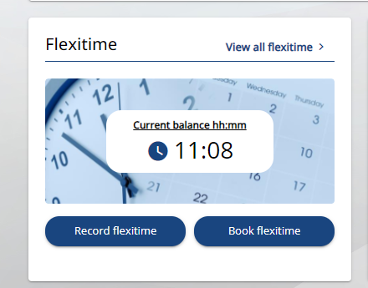

At the end of each day, you will record your start and finish times and the length of break(s) taken over the course of the day. Flexitime will accrue if you work longer than your stated working hours e.g. if you are due to work 7 hours 10 minutes as per your work pattern but work 8 hours you will accrue 50 minutes of flexitime.

Employees will also book flexi days on ESS provided they have time accrued.

Flexi can still only be accrued between the core hours of 8am – 6pm as per the Flexi Time Scheme.

A video demo of the new Flexitime system is available [here](https://eastrenfrewshire.gov.uk/changes-to-leave).

**Changes to requesting leave for employees who use Etarmis (current flexi system)**

Employees who request leave through Etarmis will now do this through Employee Self Service.  *(Exceptions do apply as indicated above).*

Annual leave entitlements will be displayed under a holiday entitlement tile as shown below on ESS and will be accessible from 26th February 2024.

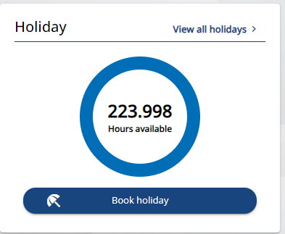

Employees’ annual leave and public holiday entitlements are now rolled together so employees have a clear depiction of their overall entitlement per leave year. To prevent employees from overusing their entitlement, public holiday dates are loaded by HR at the start of a leave year and the relevant time deducted from each employee’s record based on their work pattern. The time deducted for public holidays will still be applied the way it is just now for employees but will provide a more transparent overview as to how this is calculated over the leave year.

Annual leave for staff in this group will be booked/requested through ESS and sent to your line manager for authorisation. Time deducted from your balance will be in accordance with the working hours you are due to work over the holiday period requested.

A video demo of the new Annual Leave system is available [here](https://eastrenfrewshire.gov.uk/changes-to-leave)under the section Video Guides.

**Staff who request their leave manually (paper/email/other)**

There is no change as to how you will request your leave e.g. if you fill in a paper request form and submit to your manager you will continue to do this.

However, your leave record will be maintained in iTrent and your leave converted to hours in line with the rest of the council, if it is not already.

**IMPORTANT INFORMATION FOR GO LIVE**

**Etarmis Users**

Due to the age of the Etarmis software it has not been possible to get flexi or annual leave balances out of the system to load into ESS.

Therefore, when users log into ESS on 26.02.24 flexi balances will show, for everyone, as zero hours and annual leave entitlements will not factor in any leave carried forward from 2023 or if leave has been borrowed from 2024.

This means there are key tasks involved for managers to manually update employees’ flexi and annual leave balances. Separate communication has been sent detailing what they are required to do. However, it is worth highlighting this to staff so they are aware of the tasks that will be undertaken:

* Managers will update employee's flexi balances to reflect what is shown in Etarmis as at 23.02.24
* Managers will adjust employees annual leave to reflect carried over or borrowed leave
* Managers have been requested to complete this where possible by Monday 11th March 2024

**Non-Etarmis Users (Manual Requests)**

The above applies to this group, except for flexi, and business support/ managers will update your leave entitlement accordingly for carry forward and borrowed leave.

**Annual Leave Purchase**

Any employees who have purchased annual leave and have had this processed by HR then these amounts will be reflected on the system at Go Live, as will have been entered by HR, and do not require the manager to do this.

If you have any queries regarding your annual leave purchase these should be directed to [leaveenquiries@eastrenfrewshire.gov.uk](mailto:leaveenquiries@eastrenfrewshire.gov.uk) in the first instance.

**Leave already booked**

Employees will be required to submit any leave requests already made for 2024 on ESS to ensure continuity of balances *(Etarmis users submit online via ESS; non-Etarmis users will have their requests input by admin/managers)*

It is imperative that this is done and **includes any holidays taken between 1st January 2024 and 26th February 2024**. Managers have been instructed to ensure staff are completing this task and this can be checked against the Etarmis system as access will still be available to all who have it up until the end of March 2024.

**Staff Information**

There is a dedicated internet page set up that can be accessed by all staff [via this link](https://eastrenfrewshire.gov.uk/changes-to-leave).

The page includes all policies relating to annual leave and flexi leave and employee and manager guidance which provides more in-depth instructions as to how to navigate leave using ESS/MSS. There are also two demo videos providing an overview of the flexi and annual leave functions in ESS.

The site also contains and extensive list of FAQs which we will direct staff to in the first instance if you have any questions regarding the information in this email.

**Additional Support from Monday 26th February 2024**

There will be a dedicated hyper care team who will be on hand to answer any questions.

Queries must be submitted via email and staff should label the subject line indicating whether it relates to “Employee” or “Manager”. For clarification an employee query will be if you are asking a question about your own entitlement or process and manager will be for any manager related queries.

There will be in person support sessions scheduled following Go Live. We will give staff the opportunity to come and meet the project team and HR Representatives to ask any questions they have at both Barrhead and Eastwood HQ – dates and times to follow.

The dedicated email address for all enquiries is leaveenquiries@eastrenfrewshire.gov.uk